Software Requirements Specification
for
Project 10 – Distributed informatic system for the management of stocks and sales for a car rental company
Version 1.0

Prepared by
Group Name: Calculatoare Engleza Anul 3
Belu Florin Andrei
Barbu Constantin-Mihai
Marinescu Nanina-Andreea
Pîrvulescu Andreea-Beatrice

Instructor: | Stoica Spahiu Cosmin
Course: | Project II – Use of Databases
Date: | 14.03.2020
Table of Contents
Table of Contents ii
1 Introduction 1
1.1 Document Purpose 1
1.2 Product Scope 1
1.3 Definitions, Acronyms and Abbreviations 1
1.4 References and Acknowledgments 1
2 Overall Description 2
2.1 Product Functionality 2
2.2 End Users and Characteristics 2
2.3 System Stakeholders 2
2.4 Operating Environment 2
3 Specific Requirements 3
3.1 User Interface 3
3.2 Functional Requirements 3
3.3 Use Case Diagram 3
4 Non-functional Requirements 4
4.1 Software Quality Attributes 4
5 Other Requirements 5
5.1 Security
5.2 Safety
Appendix A - Group Log 6

Introduction
The software described in this document is a car rental service website complete with associated support pages, user interfaces, database management that allows the reservations to be made.
This document seeks to provide the Software Requirements Specifications for the car rental website, and contains an introduction, overall description, specific requirements and non-functional requirements with respect to the current stage of the project.

Document Purpose
The purpose of this document is to record the requirements for the design and
development of a car rental service website. It describes requirements for a future, complete version of the project, to be created in the spring of 2020. There may be a need for future updates to the document.
Moreover, this document reflects the current requirements of the project as understood by the project team, presenting an initial description of the various functionalities and services provided by the software. Additionally, it may also serve as a basis for testing by the user.

Product Scope
The scope of the website is not only limited to attracting and encouraging people in need of transportation and car enthusiasts to consider using the rental services, but also aims to provide relevant information and various options, keeping in mind that the person visiting this website wants a full knowledge of the availability and facilities of the vehicle to be rented. This website aims to provide a user-friendly set of web pages that are easy to navigate and at the same time provides sufficient depth and information about car rentals.
Two main potential groups of viewers exist:
1. People in need of transportation, especially tourists that need to visit multiple places in a short amount of time.
2. Car enthusiasts, people that want to test the capabilities of a certain type of vehicle before deciding whether to purchase it or not.
The goal of website is to encourage more people to choose rental services, eventually increasing the profit of the company, improvement of the services, and most importantly helping people with their business. Maintaining a simple and friendly site is deemed of highest importance in order to hold customer attention and guide the viewer to information that will lead to a decision to rent the best vehicle available.

Definitions, Acronyms and Abbreviations

XAMPP - a free and open-source cross-platform web server solution stack package developed by Apache Friends consisting mainly of the Apache HTTP Server, MariaDB database, and interpreters for scripts written in the PHP and Perl programming languages.
PHP - a popular general-purpose scripting language that is especially suited to web development.
MySQL -an open-source relational database management system.
HTML- Hypertext Markup Language is the standard markup language for documents designed to be displayed in a web browser.
CSS- Cascading Style Sheets is a style sheet language used for describing the presentation of a document written in a markup language like HTML.
MariaDB - a community-developed, commercially supported fork of the MySQL relational database management system

References and Acknowledgments
https://www.w3schools.com/
www.sixt.com
https://www.booking.com/cars.html
https://www.apachefriends.org/ro/index.html

Overall Description

Product Functionality
This website has a multitude of functionalities. The customer will be able to log in, browse a variety of cars, customize his choices and rent the perfect vehicle. He will also be recommended other vehicles based on his choices. There are also options for newsletter, personal profile and other feedback functionalities. Guests can also view customer-type functionalities of the site, but their abilities are limited.
Various pages with full support for car rental services are also implemented, covering a wide variety of options. Therefore, great interactive potential is offered.
Administrators will have full control of the database, their ability to add cars to rent, review all rented cars and statistics about the users ensures good functionality and quality. Admins can also view feedback of users.

Several goals that the site will accomplish are:

- Each brand has names and details. Each type has names and details.

- Each car is in a class (compact, limousine, etc.).

- Each class has name and description.

- There is a list of customers who have first names, email, phone, address.

- A rental history is preserved (what customer rented what car, since when to until when.).

- Each car will retain its current status (rented, unrented)

- A record of unwanted customers who have had incidents during the rental is kept.

- The company has in stock a number of cars with a license plate number, no. of km travelled, date of manufacture, a brand, type and price per hour.

End Users and Characteristics
This website will be used by three types of users.
- Admin – the administrator will be able to access a database of customers, update certain parts of it and also add car listings for the customers to rent.
- Customer – The users which have logged in are considered customers. They will be able to rent a vehicle, view their rented vehicles, receive recommendations and use various interactive options on the website such as signing up for a newsletter and sending messages to the admin.
- Guest – Users which have not logged in, have limited accessibility to the website. They will need to log in to rent vehicles and use the rest of the services, however they will still be able to browse the website fully.

There are mainly four types of customers:
1. People in need of transportation, who will regularly use the car rental services.
2. Tourists who will require a rental to get around the city easier.
3. Car enthusiasts who simply enjoy driving different cars as a hobby.
4. People that want to buy a car and prefer to ride a rental before making a decision.
If it is necessary, the website should undergo design changes to all existing pages to shorten up
paragraphs and add bullets and charts where possible to accommodate faster page reading and shorter reader attention span keeping in mind most of the users do not have great technical expertise and are looking for a simple and well-structured car presentation in order to rent it easier.

System Stakeholders
The system stakeholders could be:

Acquirers | Oversee the procurement of the system or product
Assessors | Oversee the system’s conformance to standards and legal regulation
Communicators | Explain the system to other stakeholders via its documentation and training materials
Developers | Construct and deploy the system from specifications (or lead the teams that do this)
Maintainers | Manage the evolution of the system once it is operational
Production Engineers | Design, deploy, and manage the hardware and software environments in which the system will be built, tested, and run
Support Staff | Provide support to users for the product or system when it is running
System Administrators | Run the system once it has been deployed
Testers | Test the system to ensure that it is suitable for use
Users | Define the system’s functionality and ultimately make use of it

Operating Environment

This software being developed will be compatible with machines running on Windows XP and higher.
Development will be done using XAMPP Control Panel, MySQL, Apache Server, MariaDB. The website will be written using HTML, CSS, PHP and JavaScript.
Mozilla Firefox will be the main browser used to test the website, however it will be tested on Google Chrome, Microsoft Edge, etc.
All databases and functional components will be stored on a personal computer for testing purposes. Databases and servers are handled by XAMPP control panel that will deploy Apache server and MySQL.
The hardware that will be used in developing this program consists in an Intel i5-6300HQ CPU, 8 GB RAM, Nvidia GeForce GTX 950M 4 GB. The website will work on almost any machine, so the minimum requirements are trivial. The synchronization procedures will be written to interface with Windows operating systems. There are no software components that are in conflict with this project, the website can be tested as is.

Specific Requirements

User Interface
The website will feature a home page which contains a summary of all the features, a simple, interactive presentation of some featured cars, statistics, stocks and sales information.
It will also feature an “about us” page containing information about the site owners and a car listing page which will contain the database of all available cars, complete with detailed information about all of their features and prices, including current availability.
There will also be a FAQ page with frequently asked questions about the car rental services and a “contact us” page containing contact information. There may also be buttons which contain links to social media.
The user has the ability to log in and rent a car. There is a search bar which can easily find a specific car, or it can be selected from the car listing page. Users also have access to their personal profile where they can see the bookings they have made, and can be suggested cars similar to the ones they’ve booked.
Satisfied customers, a newsletter, and a special admin login button are also available.
The website should work and be tested against Microsoft Edge, Firefox, Google Chrome.\
A wireframe model of an early version has been attached.
Note: The top two horizontal bars in the first wireframe are the header.
The bottom horizontal bar containing the additional info, admin login and newsletter is the footer.

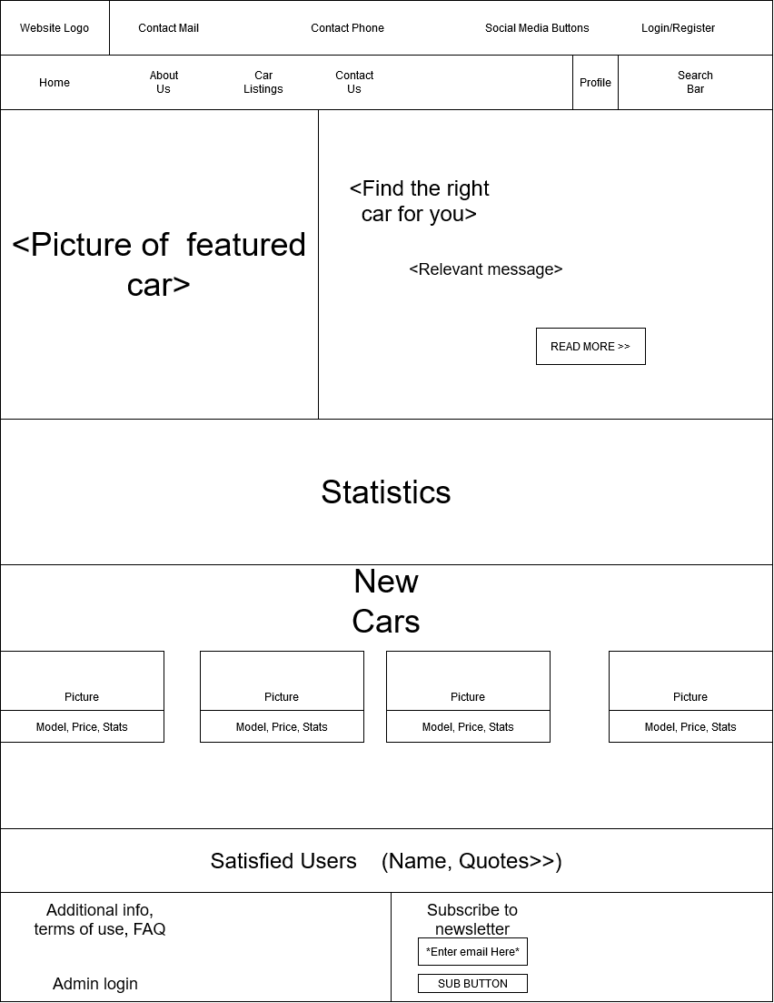
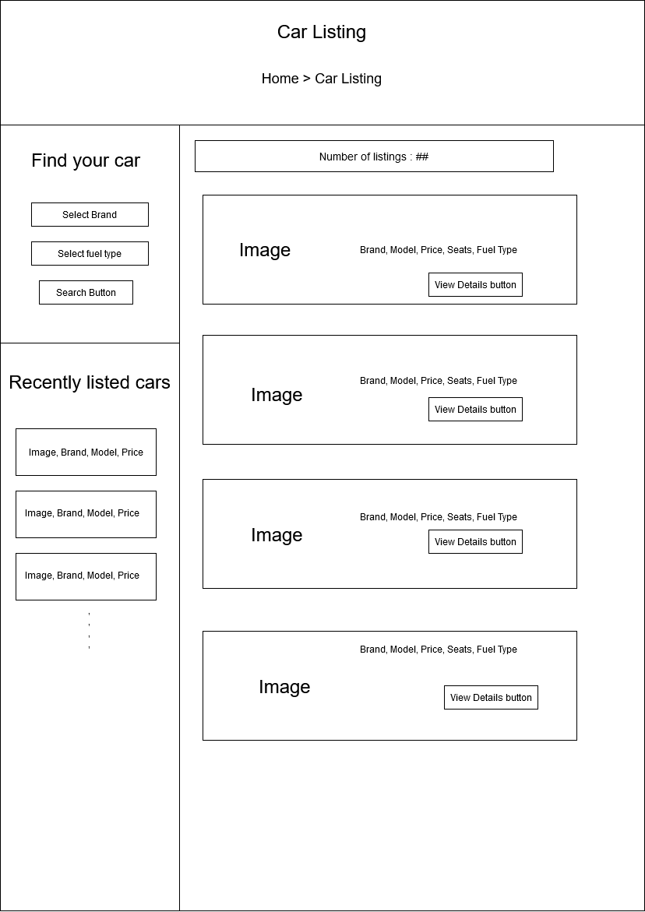

3.2 Functional Requirements

This section includes the requirements that specify all the fundamentalactions of the software system.

3.2.1 User Class 1 – The User

3.2.1.1 – A user should be able to acess th website through either a browser or similar service. The website should be free to access.
3.2.1.2 - When a new/updated version of the website is released, the user should check for these manually, however the newsletter will notify of the changes.
3.2.1.3 - Given that a user has accessed the website, then he should be able to register through the login/register service. The user must provide a name, password and e-mail address. A mobile phone number can also be introduced.
3.2.1.4 - Given that a user has registered, then the user should be able to log in to the web application. The log-in information will be stored on the browser and in the future the user can opt to be logged in automatically.
3.2.1.5 - Given that a user has registered, then the user should be able to retrieve his/her password by e-mail.
3.2.1.6 - Given that a user is logged in to the web application, then the first page that is shown should be the home page. The user should be able to search for a rental, according to several search options. The search options are Brand and Fuel type. There should also be a free-text search option. A user should be able to select multiple search options in one search.
3.2.1.7 - A user should be able to select a vehicle from the list. When a selection is made, user should be sent to the web application’s car booking page, where he can view more details about that certain vehicle. The user should then be prompted to fill in a form in order to book a car. When the booking is complete , a user should be able to go back to the search page on the web application.
3.2.1.8 – A user should be able to check their profile in order to view information about many facilities of the web application. A user should be able to update their information.
3.2.1.9 - Given that a user has accested their profile page, then the user should be able to view their bookings, and see whether they are confirmed, cancelled or pending.
3.2.1.10 - A user can post a testimonial for the administrator to see, and also view their past testimonials. This testimonial can be seen by the administrator.
3.2.1.11 – A user must be able to sign out and log in at any time. Registration process should prompt the user accordingly, depending on the requirement.

3.2.2 User Class 2 – The Administrator
3.2.2.1 –The administrator is the super-user who can manage everything on the website. Admin can log in through the special “Admin login” page found in the website footer.
3.2.2.2 – An administrator can create vehicle brands that are to appear on the web application, and can also manage them (edit, delete).
3.2.2.3 – An administrator shall be able to post a vehicle listing on the website, for every user to see and select for booking.
3.2.2.4 – An administrator can manage all bookings, in the sense that they can confirm or cancel the pending booking. This decision will be displayed on the respective user’s profile page.
3.2.2.5 – An administrator can manage testimonials, and set their status to be either active or inactive. The decision will be displayed on the respective user’s testimonial section in the profile page.
3.2.2.6 – An administrator can manage Contact us query, where users and guest users’ messages regarding their opinion and suggestions related to the website can be actively seen and read.
3.2.2.7 - Administrators can see the details of registered users, to ease the process in case any of them have problems to resolve regarding customer support.
3.2.2.8 - The administrator may update any publicly available details, such as the contact us details.
3.2.2.9 - An administrator can manage subscribers to newsletter, view their email address and remove any of them from the newsletter. The removal process is entirely at the administrator’s discrection.
3.2.2.10 – Administrators have access to the Admin dashboard, a statistics menu with values like the number of registered users, total bookings, total subscribers, total contact us queries, etc.
3.2.2.11 - An administrator is able to change his own account password inside the administrator panel.
3.2.2.12 - An administrator is able to log out of the administrator panel at any time.

3.2.3 User Class 3 – The Guest

3.2.3.1 – A guest can freely view the web application and check out the information about rental cars.
3.2.3.2 - A guest may not book a vehicle without registering and logging into their account. Anyone can register through the registration page.
3.2.3.3 – Guest users can also inquiry through the “Contact us” page.
3.2.3.4 - A guest user can become a logged-in user and vice versa, through the sign up, sign in/ sign out options.
3.2.3.5 – Guest type users may not interact with administrators.
3.2.3.6 - Guest users can subscribe to web application newsletter by entering an email, without having to log in.
3.2.3.7 – Guest users should be prompted to log in whenever performing an illegal action, such as booking a vehicle.

3.3 Use Case Diagram
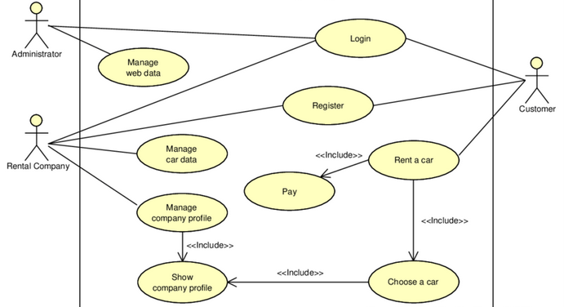

Non-functional Requirements

Software Quality Attributes
1. Usability:
- The web application shall accept customer bookings unless they are not available.
- The web application shall be able to cash in a rent fee.
- The web application shall produce a receipt detailing a customers’ purchase information and include name of customer, items purchased, cost of each item and total cost
- The web application shall be able to produce weekly, monthly and yearly reports about sales.
2. Quality:
- The web application shall contain simple, clean and easy to use interfaces
- The web application shall contain well-placed styles and layouts that fit the chosen theme.
- The web application shall provide the user with all available options at all times to satisfy quality assurance.
3. Performance:
- The web application shall contain smooth animations in drop-down menus, sliders and other related features.
- The web application shall contain fast execution times for all features.
- The web application shall manage user login support in a quick and correct manner.

4. Other attributes:
- The web application shall be easy to use by all employees including sales representatives and managers.
- The web application shall be available in several languages.
- The web application shall allow several sales to be made at the same time without downgrading performance.
- The web application representatives shall provide quick customer support for all users that have submitted a ticket.
- The web application FAQ and future updates shall be done based on the user feedback.

Other Requirements
5.1 Security

The login information is securely stored in the MySQL database. User passwords are encrypted. A “forgot password” system is available, and the user profile is also private and may not be viewed by others.

5.2 Safety

This website does not pose any threat to a person’s life.

Appendix A - Group Log
The team leader decided that the work is to be divided equally among the 4 team members. Every team member has been given permission by the leader to handle a quarter of the document. This resulting document is the work of 4 people.
Finishing touches and quality assurance are implemented by the team leader at the end.

